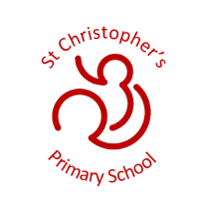
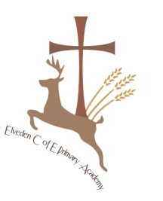
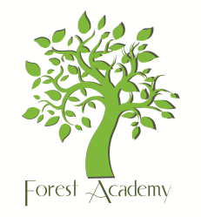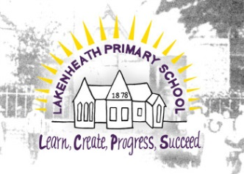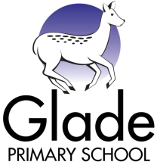

Parent and Visitor Code of Conduct

Elveden C of E Primary Academy
Forest Academy
Glade Primary School
Lakenheath Primary School
St Christopher’s Primary School
West Row Primary
Beck Row Primary Academy
St Mary’s Primary Academy
Great Heath Primary Academy

Rationale

At our schools, we are very fortunate to have supportive and friendly parents. Our parents recognise that educating children is a process that involves partnership between the home and school and understand the importance of good working relationships to equip children with the necessary skills for adulthood. For these reasons we welcome and encourage parents/carers to participate fully in school life. The purpose of this policy is to provide a reminder to all parents and visitors about the expected conduct so that we can work together to ensure a safe and positive school environment for our children.

Respect and concern for others and their rights

We expect parents and carers to show respect and concern for others by:-

- Supporting the respectful ethos of our schools by setting a good example in their own speech and behaviour towards all members of the school community;
- Working together with teachers for the benefit of children. This includes approaching school to resolve any issues of concern and to discuss and clarify specific events in order to bring about a positive solution;
- Respecting the school environment, including keeping the school tidy by not littering and returning equipment that has been borrowed.

In order to support a peaceful and safe school environment, school cannot tolerate:-

- Disruptive behaviour which interferes with the operation of a classroom, the office area, the outside learning environment or any other part of school grounds;
- Using loud and/or offensive language to intimidate or in temper;
- Threatening harm or the use of physical aggression towards another adult or child. This includes approaching someone else’s child in order to discuss or chastise them.
- Physical punishment against your own child on school premises.
- Abusive or threatening emails, phone or social network messages;

- Defamatory, offensive or derogatory comments regarding school or any of the pupils/staff, at the school on Facebook or other social sites. (See Appendix 1). Any concerns you may have about the school must be made through the appropriate channels by speaking to the class teacher, the Headteacher or the Chair of Governors, so they can be dealt with fairly, appropriately and effectively for all concerned.
- Smoking and consumption of alcohol or other drugs or accessing the school site whilst intoxicated.
- Dogs being brought onto school premises, apart from assistance dogs.

Should any of the above behaviour occur on school premises, the school may feel it necessary to contact the appropriate authorities and if necessary, even ban the offending adult(s) from entering the school grounds. We trust that parents and carers will assist our school with the implementation of this policy and thank you for your continuing support. We would expect that parents would make all persons responsible for collecting children aware of this policy.

Appendix 1 – Inappropriate use of Social Networking Sites

Social media websites are being used increasingly to fuel campaigns and complaints against schools, Headteachers, school staff, and in some cases other parents/pupils. The Governors of our schools consider the use of social media websites being used in this way as unacceptable and not in the best interests of the children or the whole school community. Any concerns you may have must be made through the appropriate channels by speaking to the class teacher, the Headteacher or the Chair of Governors, so they can be dealt with fairly, appropriately and effectively for all concerned.

In the event that any pupil or parent/carer of a child/ren being educated at any of our schools is found to be posting libellous or defamatory comments on Facebook or other social network sites, they may be reported to the appropriate 'report abuse' section of the network site. All social network sites have clear rules about the content which can be posted on the site and they provide robust mechanisms to report contact or activity which breaches this. Our schools also expect that any parent/carer or pupil removes such comments immediately.

In serious cases schools will also consider legal options to deal with any such misuse of social networking and other sites. Additionally, and perhaps more importantly is the issue of cyber bullying and the use by one child or a parent to publicly humiliate another by inappropriate use of social media. We will take and deal with this as a serious incident of school bullying. Thankfully such incidents are extremely rare.

Elveden C of E Primary Academy, Forest Academy, Glade Primary School, Lakenheath Primary School, St Christopher’s Primary School, West Row Primary, Beck Row Primary, St Mary’s Primary Academy and Great Heath Academy aim is to work collaboratively to improve the quality of education in all our schools for the benefit of all children in the Forest Heath area.

