Lower Key Stage 2
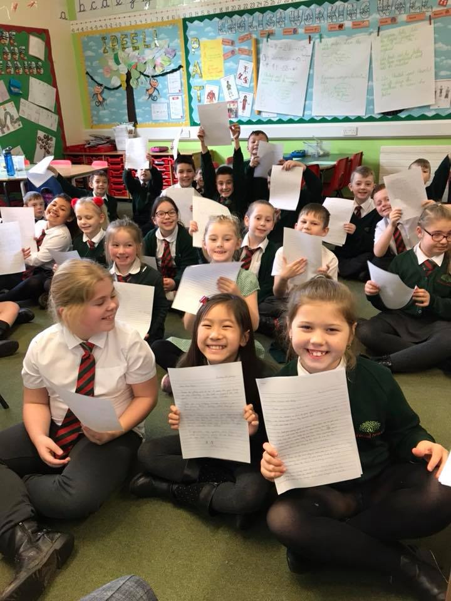
During the spring term, Lower Key Stage 2 have been learning about Asia. Our reading book has been ‘The Firework Maker’s Daughter’ by Philip Pullman. This is about a young girl called Lila who wants to become a firework-maker, like her father Lalchand. Despite her talents, Lalchand believes this is an unsuitable job for girls. Lila disagrees, and journeys to get Royal Sulphur from Razvani the Fire-Fiend at Mount Merapi, as all aspirant firework-makers must do. We have written stories all about her time in the mountains, her endeavour to save her father and written poems and painted pictures depicting the fireworks she designed.
Children in years 3 and 4 have also been writing to pupils in a school in Shanghai. This has been really interesting as it has given us a real insight in to what life is like in China. We learnt about some of their favourite foods but were surprised to find out that they did not know what a roast dinner was. In our most recent replies to our pen-pals, we included photos of us having having roast for lunch in the school hall.
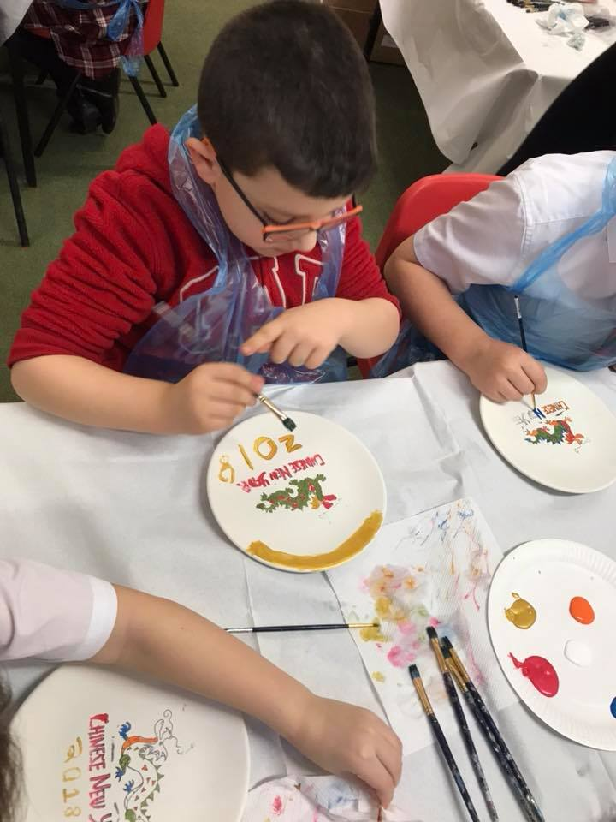
Our pen-pals are due to break up from school for two weeks to celebrate Chinese New Year. We have learnt about the celebrations involved, painting plates, dragon dancing and giving out red envelopes with messages of good fortune and luck.
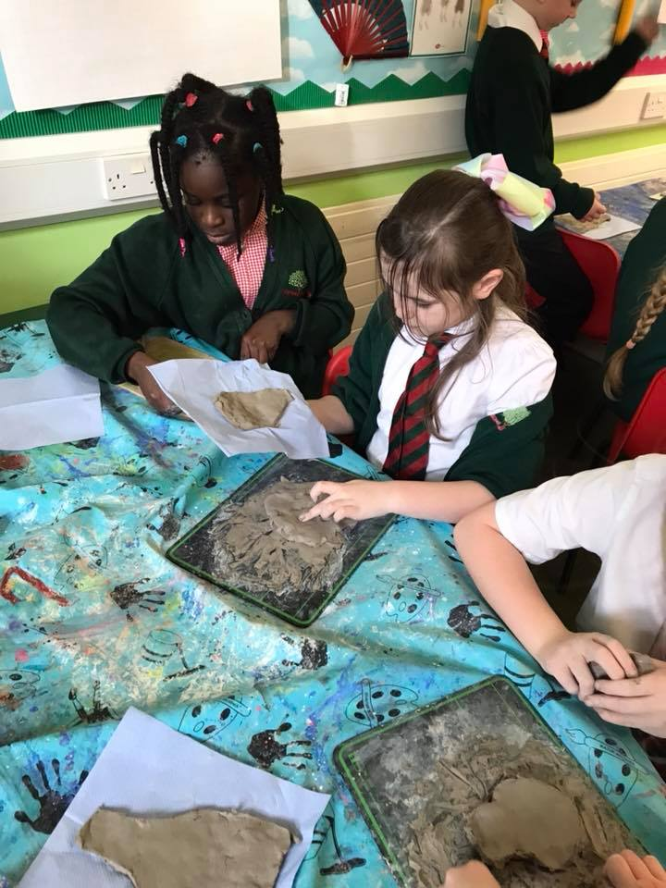
In history, we have been learning about the Shang Dynasty – an ancient Chinese civilisation. We have learnt about the importance of social hierarchy and how we can learn about the past by looking at artefacts uncovered in tombs during archaeological digs. We recreated our own oracle bones using clay and filmed our own television documentaries using pictures of the objects found.

