What a fun-filled and amazing half-term we have had learning all about America and reading our wonderful core-text ‘Holes’ by Louis Sachar. The children have looked at American geography and created some 3D models of city settlement zones as designed by Burgess. In Science, the children planned an investigation looking at the properties of money comparing American and British notes and coins and went on to study the American Artist Andy Warhol who created the Pop-Art movement.
We have started our new letter join handwriting at School and the Year 5 and 6 children have shown perseverance in adopting this new style. The writing really does look beautiful. Do ask them to show you.
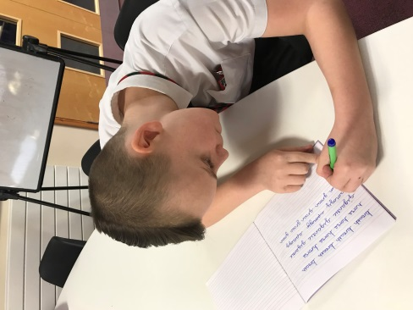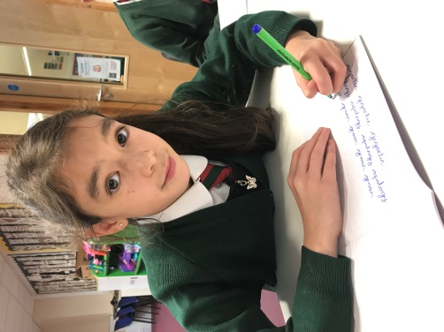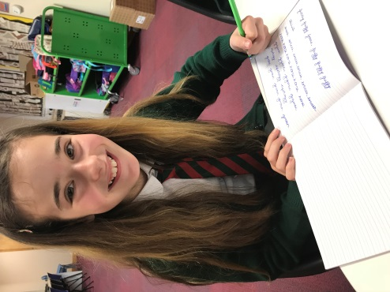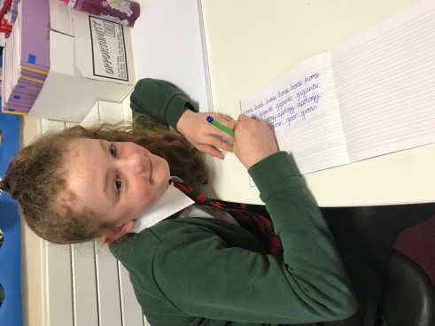
We have enjoyed learning basketball with the coaches and have been undertaking workshops on Healthy Living each week with the One Life team.

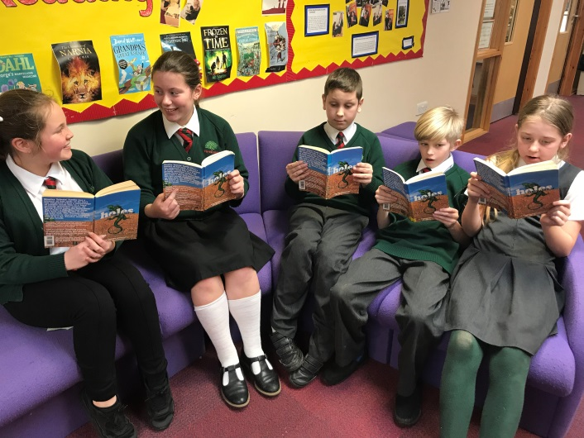
These children are enjoying reading our core-text.

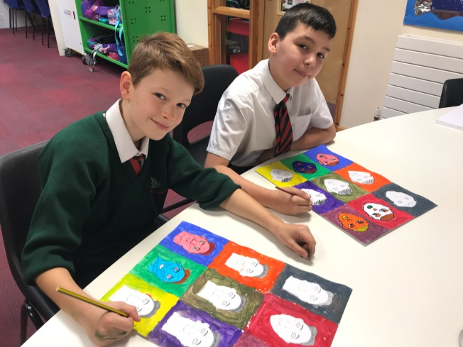
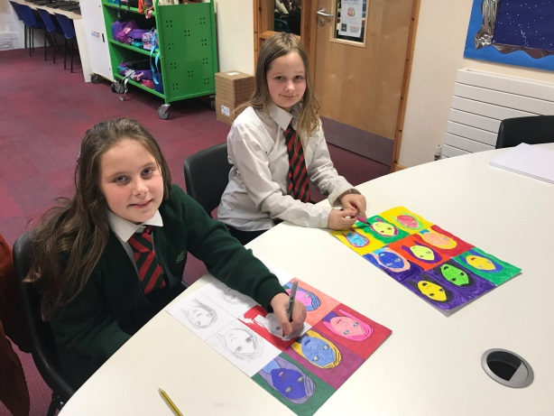
Here are 4 of our year six children creating their art-work based on Andy Warhol.

On January 30th our Basketaball team competed in the local schools’ basketball competition. They did a fantastic job working as a team. Bravo to our fabulous sports-stars! 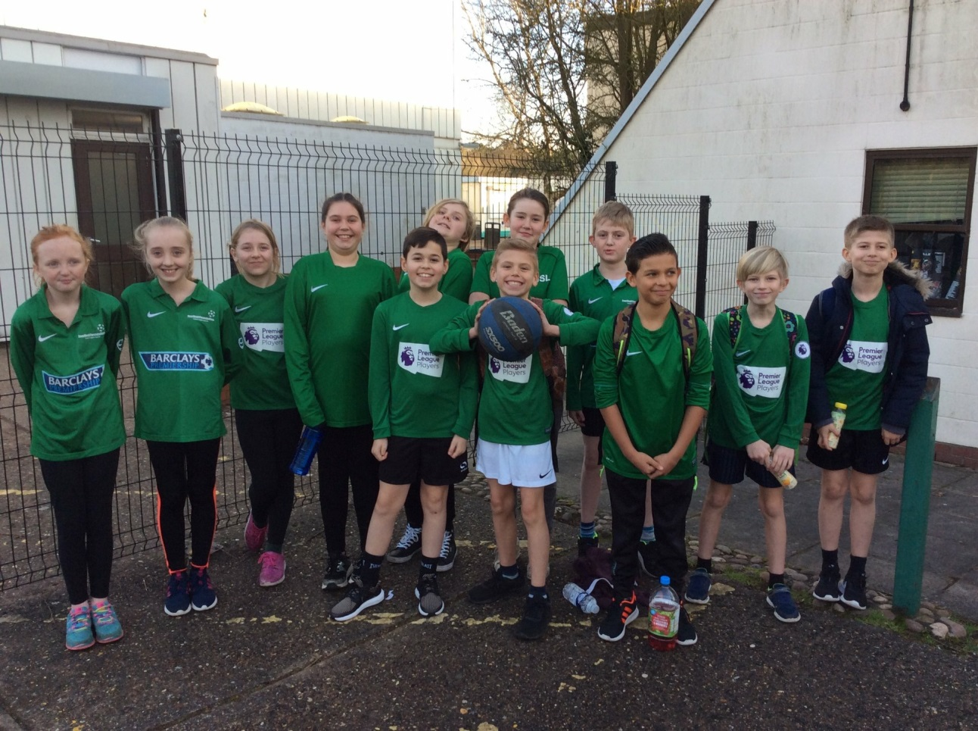

Next term, we will be studying South America focusing on the rainforest. We cannot wait.

