 | Forest Academy Long-Term Plan 2020-21
 | Year 3 and Year 4 (LKS2) Cycle B
Term | Autumn 1st | Autumn 2nd | Spring 1st and 2nd |  |  |  | Summer 1st | Summer 2nd
Topic | Anglo Saxons | Rainforests | Vikings |  |  |  | WW2 | Splish, Splash, Splosh
English Reading Y3 | 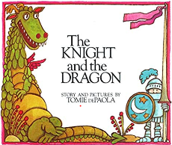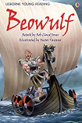 | 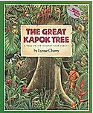 | 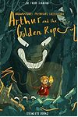 |  |  | Shakespeare Week |  | 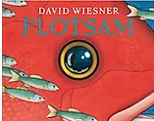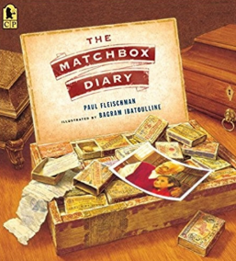
English Reading Y4 | 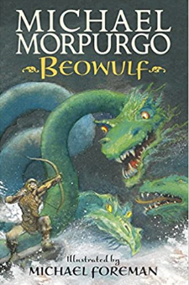 | 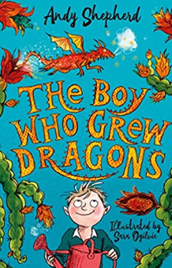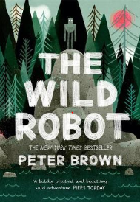 | 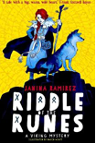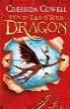 |  |  |  | 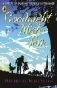 | 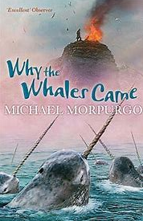
Poetry |  | The Puffin Book of Utterly Brilliant Poetry | Sensational: poems inspired by the five sense – Roger McGough |  |  |  |  | Hello H20 – Jogn Agard
English Writing | National Curriculum objectives to be covered progressively using Jonathan Bond’s ‘English Planning Toolkit’ – termly objectives cover speaking and listening, reading and writing.  Progression of text types, with a clear purpose for writing (IPEELL), to be covered over the two-year cycle:  Text types Writing to entertain Writing to inform Writing to persuade  - Stories - Description - Poetry (see Pie Corbett’s Poetry Spine) - Characters/settings - Explanation - Recount - Letter - Biography - Newspaper article - Advertising - Letter - Speech - Poster
Maths | White Rose Maths LTPs | White Rose Maths LTPs | White Rose Maths LTPs |  |  |  | White Rose Maths LTPs |  | White Rose Maths LTPs
Science  (PLAN) | Animals including humans (skeletons/muscles) | Living things and habitats | Animals including humans (digestion/teeth) |  |  |  | Sound |  | States of matter
 |  |  | Science Week – whole school theme
Computing  Y3 | Unit 3.1 Coding | Unit 3.2 Online safety  Unit 3.3 Spreadsheets | Unit 3.6 Branching Databases |  | Unit 3.7 Simulations  Unit 3.4 Touch-typing |  | Unit 3.5 Email |  | Unit 3.8 Graphing
Computing  Y4 | Unit 4.1 Coding | Unit 4.2 Online Safety  Unit 4.7 Effective searching | Unit 4.3 Spreadsheets |  | Unit 4.4 Writing for different audiences |  | Unit 4.5 Logo |  | Unit 4.6 Animation  Unit 4.8 Hardware investigators
PE Skills  Real PE | Unit 1  Developing personal skills | Unit 2  Developing social skills | Unit 3  Developing cognitive skills-problem solving |  | Unit 4  Developing creative skills |  | Unit 5  Developing physical skills |  | Unit 6  Health and Fitness
PE Themes Y3 | Athletics | Dance | Football |  | Swimming |  | Swimming |  | Tri-golf
PE Themes Y4 | Hockey | Swimming | Swimming |  | Gymnastics |  | Mini-tennis |  | Kwick Cricket
History | Britain’s settlement by Anglo-Saxons and Scots  (To include local history studies – Sutton Hoo on the Suffolk coast, St Edmund of East Anglia) |  | The Viking and Anglo-Saxon struggle for the Kingdom of England to the time of Edward the Confessor |  |  |  | British history beyond 1066 –  WW2: a significant turning point – The Battle of Britain  (To include a local study of evacuees sent to Brandon and attending Forest Academy. Source: Head teacher log book)
Geography |  | Place Knowledge  Rainforests – locate areas of the world that contain rainforests and describe key aspects of a tropical climate. Compare to Thetford Forest. | Fieldwork  Fieldwork to observe, measure, record and present the human and physical features in the local area. Map work |  |  |  |  |  | Human and physical geography  Undertake weather studies – recording changes and observations  The Water Cycle  Plastic pollution in the ocean – a debate
Art and Design | Collage  Dragons |  | Materials and textiles  Bayeux Tapestry |  |  |  |  |  | Painting  Monet (famous artist study)
Amazing Artists | Picasso:  1881-1973 | Cezanne:  1839-1906 | Lichtenstein:  1923-1997 |  | Constable:  1776 – 1837 |  | Georgia O’Keeffe:  1887-1986 |  | Banksy:  1974 -
Design and Technology |  | Food  How cool is your drink? |  |  | Textiles  How should your puppet tell their story? |  | Structures  How will you store your favourite things?
French | Rigolo 1  Unit 7: Encore | Rigolo 1  Unit 8: Quelle heure est-il | Rigolo 1  Unit 9: Les fetes |  | Rigolo 1  Unit 10: Ou vas-tu? |  | Rigolo 1  Unit 11: En mange |  | Rigolo 1  Unit 12: Les cirque
Music  Charanga Y3 | Let your spirit fly | Glockenspiel 1 | Three little birds  The dragon song |  |  |  | Bring us together |  | Reflect, Rewind and Replay
Music  Charanga Y4 | Mamma Mia | Glockenspiel 2 | STOP!  Lean on me |  |  |  | Blackbird |  | Reflect. Rewind and Replay
PSHE Y3  (Cambridgeshire Scheme) | Beginning and Belonging  My Emotions | Working Together | Diversity and Communities | Managing Safety and Risk |  |  | Digital Lifestyles |  | Relationships and Sex Education  Healthy Lifestyles
PSHE Y4  (Cambridgeshire Scheme) | Rights Rules and Responsibilities  Family and Friends | Anti-bullying | Financial Capability | Drug Education |  |  | Personal Safety |  | Relationships and Sex Education  Managing Change
RE | Hinduism  Why does Hindu want to collect good karma? | Judaism  What symbols and stories help Jewish people remember their covenant with God?  (Hanukah) | Christianity |  |  |  | Islam  How does a Muslim show their submission and obedience to Allah? |  | Sikhism  How do Sikhs put their beliefs about equality into practise?
 |  |  | What doe Christians mean when they talk about the kingdom of God? |  | Is the cross a symbol of love, sacrifice or commitment for Christians?
Forest Schools/Outdoor learning | Forest Schools/Outdoor learning
SMSC Days | Social Day |  | Spiritual Day |  |  |  | Cultural Day |  | Moral Day
Enrichment Opportunities | Children to present about good karma and random acts of kindness – BLP assembly.  World Mental Health Day  National Poetry Day (October)  Harvest Festival | Children in Need – charity event  Pantomime visit  Christmas carols in the community | Portals to the Past – Viking visitor  Safer Internet Day (February)  World Book Day (March)  Visit from local dentist  Computational thinking – Adastral Park (Year 3)  Divergent drama – Shakespeare  LKS2 Production  Young Voices |  |  |  | VE DAY  Careers Fayre |  | Sports Day
Visit  Opportunities | Tomorrow’s Achievers: Anglo Saxon Day  West Stow  Sutton Hoo |  | School Farm and Country Fair – yr 3 (April) |  |  |  | Duxford

