 | Forest Academy Long-Term Plan 2021-22
 | Year 1 and Year 2 (KS1) Cycle A
Term | Autumn 1st | Autumn 2nd | Spring 1st | Spring 2nd |  | Summer 1st |  | Summer 2nd
Topic | All About Me | Pole to Pole | Australia Here We Come! | Once Upon A Time |  | Great Explorers |  | London
English Reading Y1 | 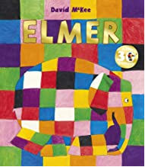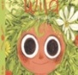 | 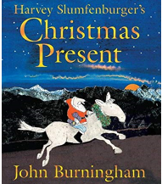 | 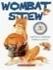  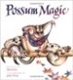 | 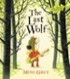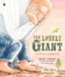 | Shakespeare Week | 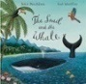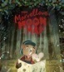 |  | 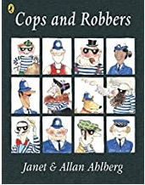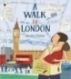
English Reading Y2 | 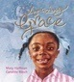 | 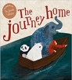 | 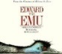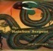 | 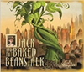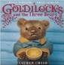 |  | 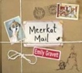 |  | 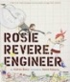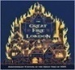
Poetry | Happy Poem by James Carter (Pie Corbett – The Works) |  | Kangaroos by Roger John Cotton  (Pie Corbett – The Works) |  |  |  |  | The Great Fire of London poem by George Szirtes
English Writing | National Curriculum objectives to be covered progressively using Jonathan Bond’s ‘English Planning Toolkit’ – termly objectives cover speaking and listening, reading and writing.  Progression of text types, with a clear purpose for writing to be covered over the two-year cycle (Talk for Writing):  Text types Writing to entertain Writing to inform  - Stories (including re-tellings) - Descriptions - Poetry (see Pie Corbett’s Poetry Spine) - In-character/role - Recount - Letter - Instructions
Maths | White Rose Maths LTPs | White Rose Maths LTPs | White Rose Maths LTPs | White Rose Maths LTPs |  | White Rose Maths LTPs | White Rose Maths LTPs
Science  (PLAN) | Animals Including Humans  Name and label parts of the human body. Say what part of the body is linked to each sense | Seasonal Changes  Observe the changes in seasons. | Animals Including Humans  Describe and compare the structure of different animals. | Plants  Plant beans and observe how they grow over time. |  | Living Things and Their Habitats  Explore different habitats. | Everyday Materials  Children to go on a materials hunt. They will identify and describe the different materials.
 |  |  |  | Science Week – whole school theme
Computing  Y1 | Purple Mash Unit 1.1 Online safety  Purple Mash Unit 1.2 Grouping and soring | Purple Mash Unit 1.3  Pictograms | Purple Mash Unit 1.4 Lego builders | Purple Mash Unit 1.5 Maze Explorers |  | Purple Mash Unit 1.6  Animated stories  Purple Mash Unit 1.7 Coding | Purple Mash Unit 1.8  Spreadsheets  Purple Mash Unit 1.9  Technology Outside
Computing  Y2 | Purple Mash Unit 2.1 Coding  Purple Mash Unit 2.2  Online safety | Purple Mash Unit 2.3  Spreadsheets | Purple Mash Unit 2.4  Questioning | Purple Mash Unit 2.5 Effective searching. |  | Purple Mash Unit 2.6 Creating pictures | Purple Mash Unit 2.7  Making music  Purple Mash Unit 2.8  Presenting ideas.
PE Skills  Real PE | Real PE: Unit 1  Personal Skills | Real PE: Unit 2  Social Skills in Sport | Real PE: Unit 3  Cognitive Skills | Real PE: Unit 4  Creative Skills |  | Real PE: Unit 5  Applying Physical Skills | Real PE: Unit 6  Health and Fitness
PE Themes | Multi-skills | Gymnastics | Invasion Games | Dance |  | Circuit Training | Scatter Rounders
History | Change within living memory:  Timelines – children to create a timeline of their own lives |  |  | Change within living memory:  Castles and homes  What was life like in a Norman home? |  | Significant Individuals:  Children to compare the lives of Christopher Columbus and Neil Armstrong | Significant Events in own Locality:  Children to look at Great Fire of London in 1666 and will compare it to the Great Fire of Brandon.
Geography | Fieldwork:  Investigating and creating maps of the school grounds  Themed walk around Brandon looking for human and physical features | Human and Physical:  Children to look at the seasonal weather patterns.  Children to look at the weather at the poles and compare to the weather in Brandon. | Place Knowledge:  Children to complete the GA unit “Australia Here We Come”.  Children to make comparison to life in parts of Australia to here in the UK |  |  | Orienteering:  Children to have a day developing their compass skills and orienteering skills around the school grounds | Map Work:  Children to create maps of landmarks along the River Thames. Children to use compass directions to describe the locations of landmarks on their maps.
Art and Design |  | Painting & Drawing:  Explore colour mixing as they look at creating paintings representing the different seasons. Look at the work of Arcimboldo for inspiration | Materials and Textiles:  Look at aboriginal dot paintings. Create a rain maker, decorated with their dot painting patterns. |  |  | Painting and Collage  Recreate a scene from space using mixed media. | Collage:  Create a collage of the Great Fire of London.
Amazing Artists | Matisse: 1869 -1954 | Van Gogh: 1853-1890 | Kandinsky: 1866-1944 | Turner: 1775-1851 |  | Seurat: 1859-1891 | Frida Kahlo: 1907-1954
Design and Technology | Food:  How do you like your toast?  Children to make toast and add their favourite toast. |  |  | Structures:  How would you protect a castle?  Children to design and make a castle. |  | Textiles:  What can you learn from a textile tree?  Children to create a textile tree.
Music  Charanga Y1 | Hey You | Rhythm in the Way We Walk  The Banana Rap | In the Groove | Round and Round |  | Your Imagination | Reflect, Rewind and Replay
Music  Charanga Y2 | Hands, Feet, Heart. | Ho Ho Ho | I Wanna Play in a Band | Zootime |  | Friendship Song | Reflect, Rewind, Replay
PSHE Y1  (Cambridgeshire Scheme) | Beginning and Belonging  My Emotions | Working Together | Diversity and Communities | Managing Safety and Risk |  | Digital Lifestyles | Relationships and Sex Education  Healthy Lifestyles
PSHE Y2  (Cambridgeshire Scheme) | Rights Rules and Responsibilities  Family and Friends | Anti-bullying | Financial Capability | Drug Education |  | Personal Safety | Relationships and Sex Education  Managing Change
RE | Christianity  What did Jesus teach about God and his parables? | Christianity  Why was Jesus given the name Saviour? | Judaism  Why do Jewish families talk about repentance at New Year? | Christianity  What are the best symbols of Jesus’ death and resurrection at Easter? |  | Judaism  Why is learning to do good deeds so important to Jewish people? | Christianity  Why do Christians trust Jesus and follow him?
SMSC Days | Social Day |  | Spiritual Day |  |  | Cultural Day | Moral Day
Forest School/Outdoor Learning | Forest School/Outdoor Learning
Enrichment Opportunities | National Poetry Day  World Mental Health Day | Children in Need – charity event  Pantomime visit  Christmas Concert | Australia Day  Safer Internet Day | World Book Day  Shakespeare Week & Divergent Drama |  | Orienteering Day |  | The Great Fire of London Day  Sports Day
Visit  Opportunities | Themed Walk around Brandon |  | Zoo Lab – Australian Animals  Faith speaker visit | Mountfitchet Castle |  | Wonderdome – Mobile Planetarium |  | Trip to London for a River Thames Boat Ride (Cutty Sark to Westminster Bridge)

