Forest’s Fantastic Reads!
Year 5

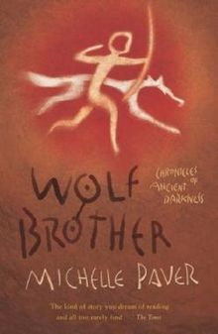 | 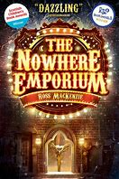 | 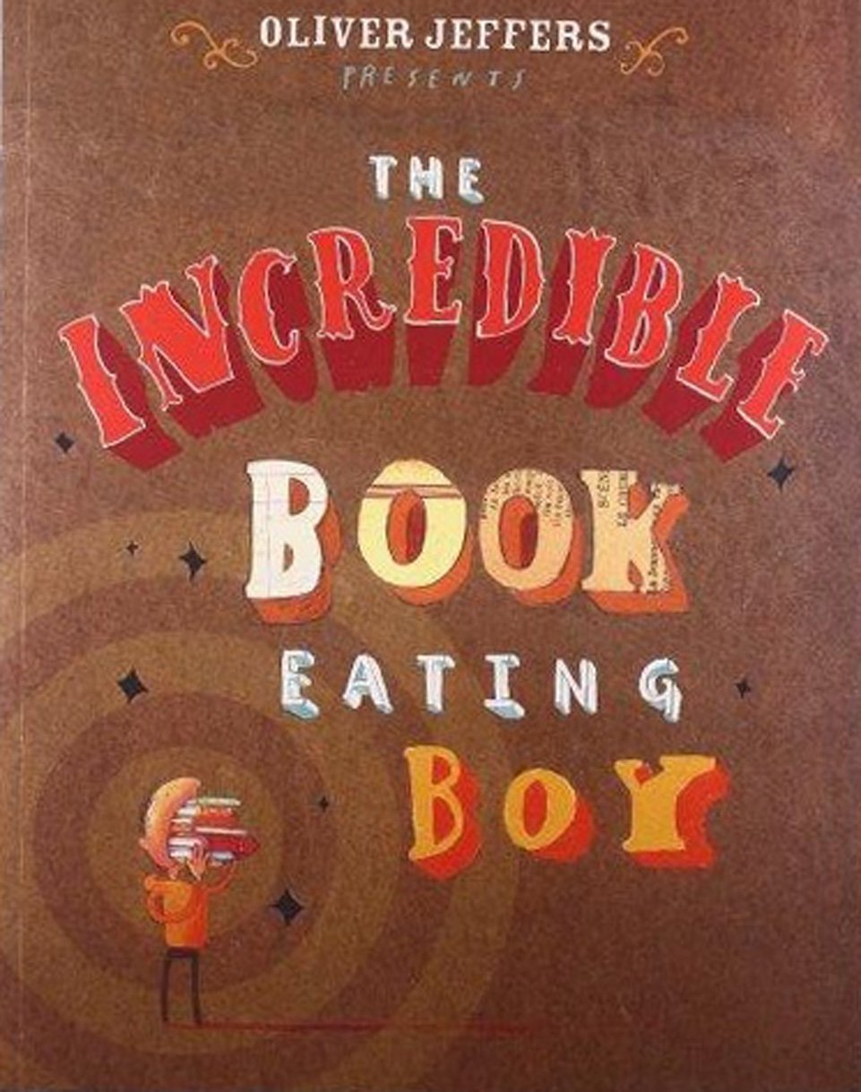 | 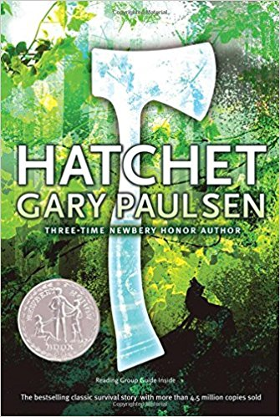 | 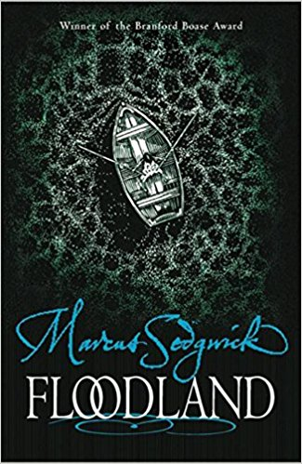
Date read: | Date read: | Date read: | Date read: | Date read:
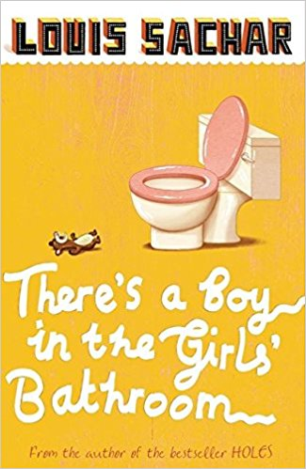 | 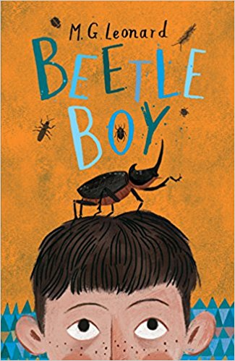 | 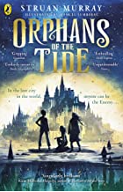 | 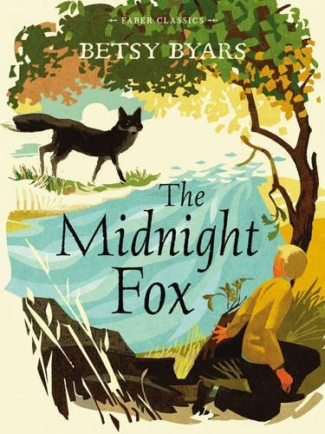 | 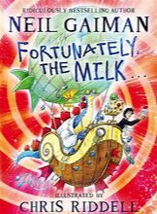
Date read: | Date read: | Date read: | Date read: | Date read:
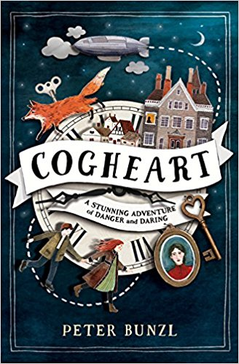 | 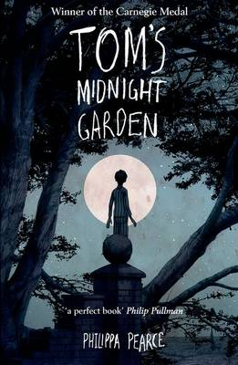 | 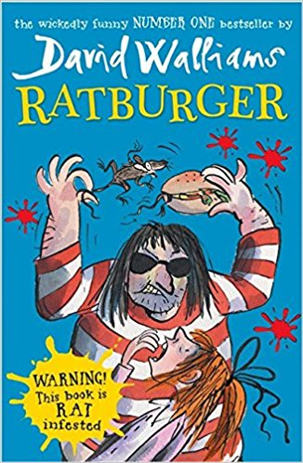 | 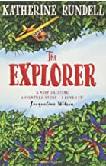 | 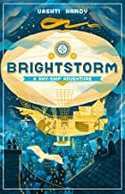
Date read: | Date read: | Date read: | Date read: | Date read:
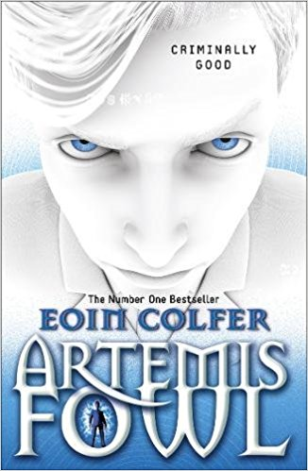 | 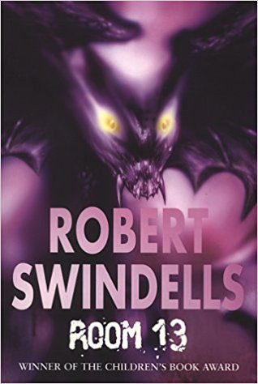 | 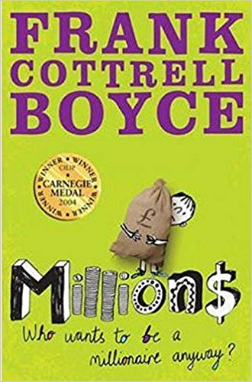 | 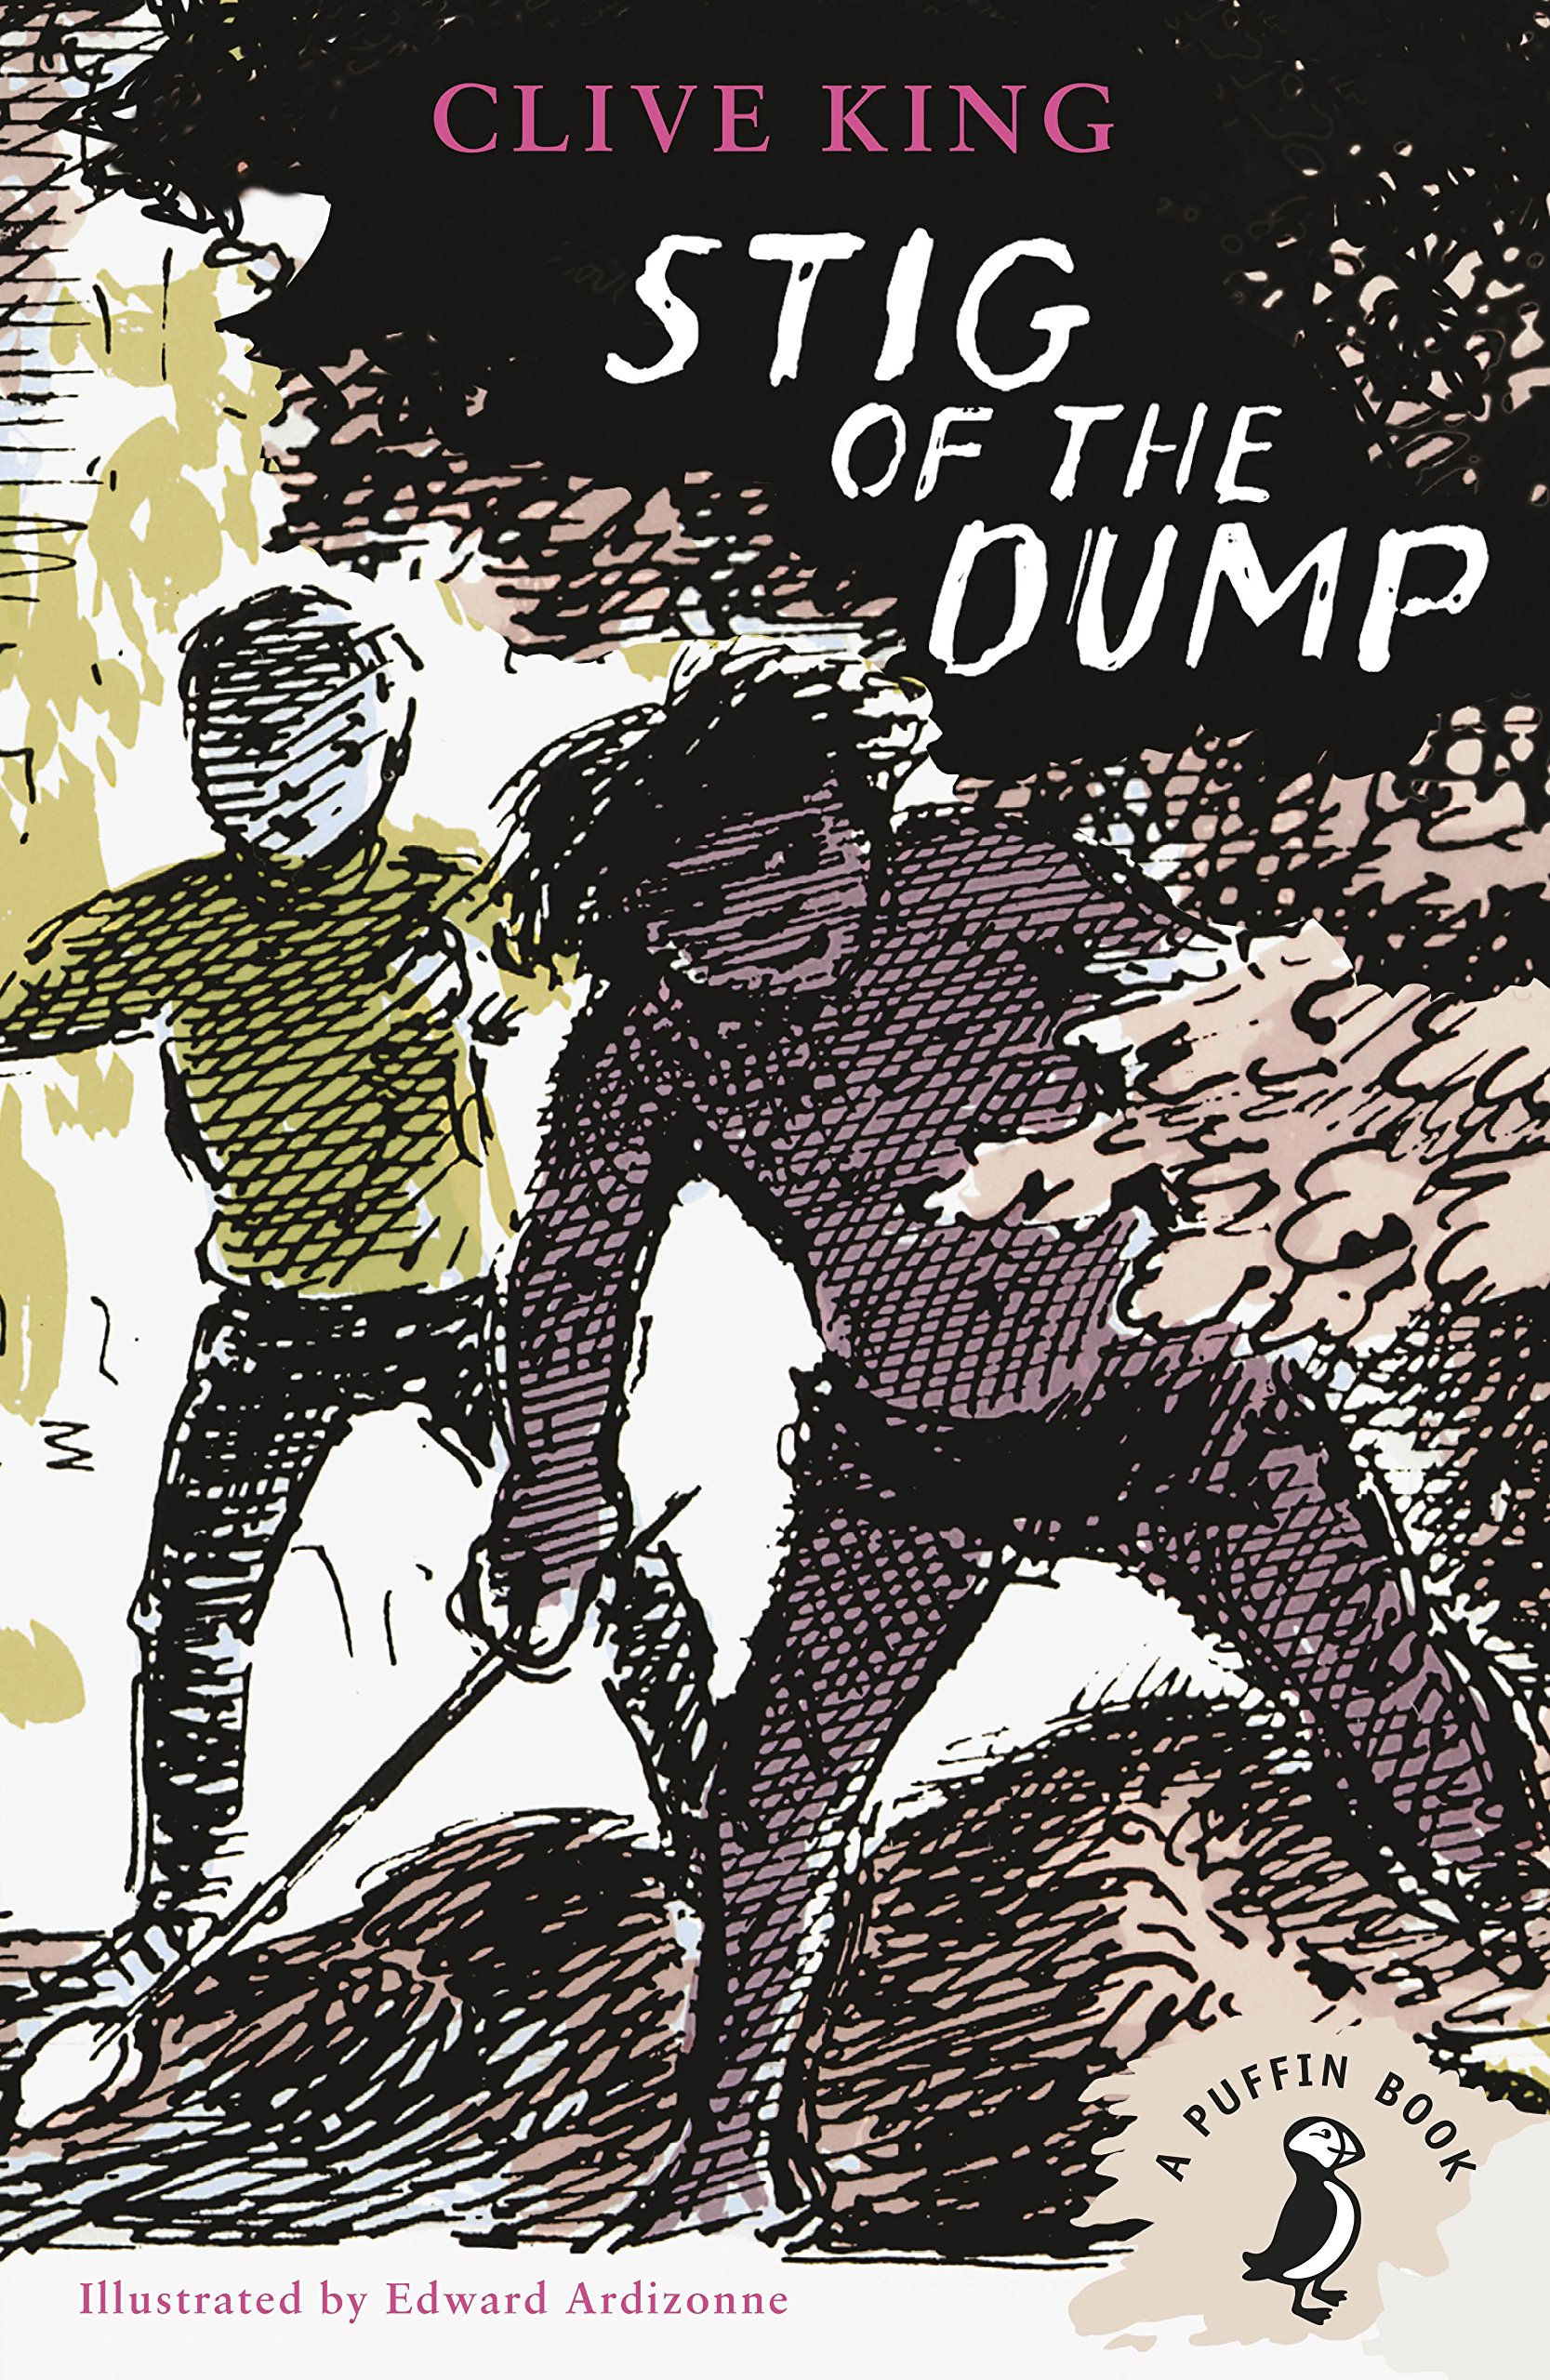 | 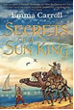
Date read: | Date read: | Date read: | Date read: | Date read:

Once you have enjoyed a fiction book from the list above, ask your grown up to sign your reading diary, complete a book review and then your teacher can tick and date your chart.  5 books read = a bronze certificate  10 books read = a silver certificate  15 books read = a gold certificate  20 books read = a special prize! |  | Why not try these non-fiction books too? These are just for fun and will enhance the work you do in your topic lessons!
 |  | 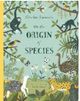 | 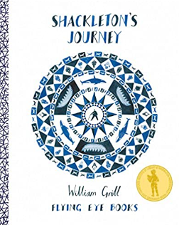 | 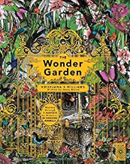
 |  | Date read: | Date read: | Date read:

