Forest Academy
&
Elveden Church of England Primary Academy
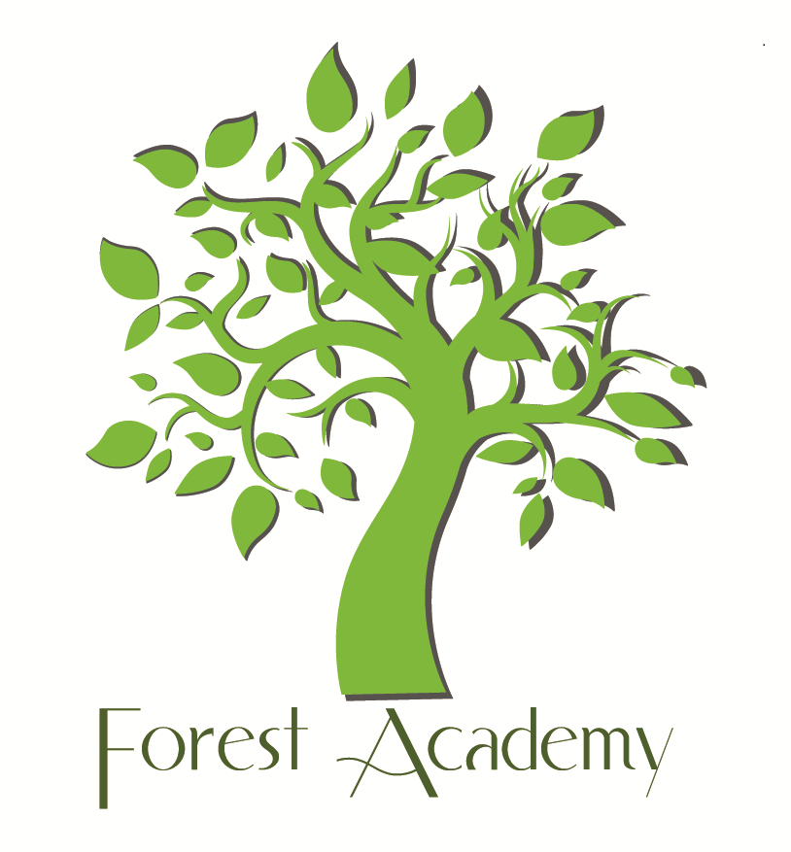

Special Educational Needs and Disability (SEND) Policy

Date Completed: September 2014
Completed by: Zoe Huff
Reviewed: March 2018
Review Date: March 2019
Forest Academy and Elveden C of E Primary Academy
Special Educational Needs and Disability (SEND) Policy
Forest Academy and Elveden Academy are inclusive schools. We take safeguarding very seriously and all of our policies are developed with a high priority on children’s safety and in the light of our safeguarding policy. All of our school policies are interlinked and should be read and informed by all other policies. In particular, the SEND policy is linked to behaviour, anti-bullying, medical and curriculum policies.

Forest Academy and Elveden Academy are part of the Mildenhall SEN Hub which is a partnership of 8 local primary schools, working together to improve provision for children with SEND. Together with the other schools, we have produced a guide for parents of children with SEN. The Mildenhall Hub SEN Information is available from our website and is a comprehensive set of Frequently Asked Question which explains how all of the Hub schools support children and parents. The Mildenhall Hub SEN Information was produced in conjunction with parents from all of our hub schools. The website also includes a link to Suffolk’s Local Offer for parents and children with SEN and disabilities.

This SEND policy is written to comply with the 2014 Children and Families Act and its SEN Code of Practice together with the Equality Act 2010. In relation to the admission of pupils with disabilities, please see our accessibility plan.

The SEND team at Forest Academy
Inquiries about an individual child’s progress should be addressed at first to the class teacher since he or she is the person who knows the child best. Other enquiries can be addressed to
Zoe Huff - SENCo
Please make an appointment with the school office if you wish to speak to the SENCo.

Headlines from the 2014 Code of Practice. From September 2014
- No more statements will be issued by the Local Authority. Statements have been replaced by Education, Health and Care plans (EHC Plans) which can be used to support children from birth-25 years.
- School Action and School Action Plus have been replaced by one school based category of Need known as ‘Special Education Needs Support’ (SENS). All children are closely monitored, and their progress tracked each term. Those at SENS are additionally tracked by the SENCo.
- There are four broad categories of SEN:
  - communication and interaction
  - cognition and learning
  - social, emotional and mental health
  - physical and sensory.
We have children in all these categories of SEN.
- We are working more closely with parents and children to ensure that take into account the child’s own views and aspirations and the parents’ experience of, and hopes for, their child. Parents are invited to be involved at every stage of planning and reviewing SEN provision for their child.
- All children benefit from ‘Quality First Teaching’: this means that teachers expect to assess, plan and teach all children at the level which allows them to make progress with their learning. In addition, we implement some focused interventions to target particular skills.
- We have high expectations of all our children. Children on our SEN register make progress which compares well with the progress made by other children in school.
Defining SEN
The 2014 Code of Practice says that:
A person has SEN if they have a learning difficulty or disability which calls for special educational provision to be made for him or her. At compulsory school age this means he or she has a significantly greater difficulty in learning than the majority of others the same age, or, has a disability which prevents or hinders him or her from making use of facilities of a kind generally provided for others of the same age in mainstream schools. Taken from 2014 SEN Code of Practice: 0 to 25 Years – Introduction xiii and xiv

SEN at Forest Academy and Elveden Academy
Our objectives are:
- To identify, at the earliest possible opportunity, barriers to learning and participation for pupils with SEND; (see also curriculum and assessment policies)
- To ensure that every child experiences success in their learning and achieves to the highest possible standard ;
- To enable all children to participate in lessons fully and effectively
- To value and encourage the contribution of all children to the life of the school
- To work in partnership with parents
- To work with the Governing Body to enable them to fulfil their statutory monitoring role with regard to the Policy Statement for SEND
- To work closely with external support agencies, where appropriate, to support the need of individual pupils
- To ensure that all staff have access to training and advice to support quality teaching and learning for all pupils

Around 10% of our children are either at SENS (SEN support) or have EHC Plans (Education, Health and Care Plans). This is below the national average but means that all teachers expect to have children with SEND in their classes.

Types of SEND which we currently have in school, during 2017-2018 include children with a diagnosis as well as those with learning profiles consistent with the diagnosis:
Communication and Interaction
- autistic spectrum and language disorders
Cognition and Learning
- dyslexia, dyspraxia and dyscalculia; moderate learning difficulties, global developmental delay.
Social, Emotional and Mental Health
- ADHD, ADD, attachment disorders, emotional difficulties, mental health difficulties
Physical and Sensory
- Hearing impaired,
Medical Needs
- Epilepsy, bowel disorders and diabetes

Identifying children at SENS (SEN Support)
Children with SEN are identified by one of three assessment routes all of which are part of the overall approach to monitoring progress of all pupils. Forest and Elveden use the Suffolk guidance for identification of our SEN pupils.
- The progress of every child is monitored at termly pupil progress meetings. Where children are identified as not making progress in spite of Quality First Teaching they are discussed with the SENCo or Inclusion Manager and a plan of action is agreed.
- Class teachers are continually aware of children’s learning. If they observe that a child, as recommended by the 2014 Code of Practice, is making less than expected progress, given their age and individual circumstances, they will seek to identify a cause. This can be characterised by progress which:
- is significantly slower than that of their peers starting from the same baseline
• fails to match or better the child’s previous rate of progress
• fails to close the attainment gap between the child and their peers
- Parents sometimes ask us to look more closely at their child’s learning. We take all parental requests seriously and investigate them all. Frequently, the concern can be addressed by Quality First Teaching or some parental support. Otherwise, the child is placed at SEN on our SEN register.
We use qualified advisors to undertake a range of standardised tests with children. These can be used to add to and inform teachers’ own understanding and assessment of a child.
Although the school can identify special educational needs, and make provision to meet those needs, we do not offer diagnoses. Parents are advised to contact their GP if they think their child may have ASD or ADHD or some other disability.

Working with Parents and Children
We aim to have good and informative relationships with all of our parents. If a child is experiencing difficulties, parents will be informed either at parents’ meetings (autumn and spring terms) or during informal meetings to discuss the child’s progress. It shouldn’t come as a surprise to a parent to learn that their child is being identified as having SEN.
Once a child has been identified as having SEN, the class teacher will invite the parents to a meeting to:
- formally let them know that their child is being placed at SENS
- discuss assessments that have been completed
- agree a plan and provision for the next term.
This is part of the graduated approach cycle of ‘Assess, Plan, Do, Review ‘required in the Code of Practice.
Depending on their age, and their interest, the child may be invited to attend all or part of the meeting.
Records are kept of these meetings and copies are available to parents.
Thereafter, parents – and children- are invited to a meeting at least each term to review progress made, set targets and agree provision for the next term. In the summer term, there is an annual review of the child’s progress.

Paperwork for children at SENS (SEN support)
Once a child has been identified as needing SENS the following paperwork is completed:
- Annually, a one-page-plan is used to record the child’s strengths and interests, what they enjoy about school, what they find hard and what helps them to achieve. This is completed with the child and parent and acts as a guide to their class teacher. The information may be updated during the year.
- Termly, at progress meetings, an Individual Support Profile, (like an ISP) is produced and/or reviewed. The plan records specific and challenging targets for the child to achieve in a term, together with the personalised provision (which may be 1-1 or in a small group) put in place to enable the child to achieve these targets.
- Monthly, at a progress meeting, smaller targets taken directly from the Individual Support Profile are discussed with children and parents and agreed next steps are recorded towards the longer term targets.
- Weekly, on tracking records the teacher or teaching assistant records a short comment about progress made towards each of the targets.
Moving to an EHCP (Education, Health and Care Plan)
If children fail to make progress, in spite of high quality, targeted support at SENS, we may apply for the child to be assessed for an EHC Plan. Generally, we apply for an EHC Plan if:
- The child is Looked After and therefore additionally vulnerable
- The child has a disability which is lifelong and which means that they will always need support to learn effectively
- The child’s achievements are so far below their peers that we think it likely that the child may at some point benefit from special school provision.
Children, who we think will manage in mainstream schools, albeit with support, are less often assessed for EHC Plans. Having a diagnosis (e.g. of ASD, ADHD or dyslexia) does not mean that a child needs an EHC Plan.
If the application for an EHC Plan is successful, a member of the Local Authority will call a meeting for parents, the child and the school together with any health or social care professionals who are involved with the family. The meeting will record the child’s strengths, their dreams and aspirations as well as the barriers they face. Following the meeting, the LA will produce the EHC Plan which will record the decisions made at the meeting.
Teaching and Learning
We believe that all children learn best with the rest of their class. Our aim is for all children to be working independently, in class, at the cusp of their potential. Children with SEN and disabilities are entitled to be taught by their teacher, not always by a TA. Teachers aim to spend time each day working with all children with SEN, individually or as part of a group.
When allocating additional TA support to children, our focus is on outcomes, not hours: we aim to put in sufficient support to enable the child to reach their challenging targets, but without developing a learned dependence on an adult.
The school has a range of interventions available which are listed and costed on a provision map. When considering an intervention, we look first at the child’s profile of learning in order that we can select the intervention which is best matched to the child.
Targets for children at SENS are deliberately challenging in the attempt to close the attainment gap between the children and their peers. Interventions are often crucial in closing these gaps, so are monitored closely by both the class teacher- who monitors progress towards the targets during the intervention- and by the SENCo who monitors overall progress after the intervention.
- Interventions are planned in half termly blocks.
- At the end of each block, children’s progress towards their targets is assessed and recorded.
- A decision is them made as to whether to continue the intervention, to swap to a new intervention, or to allow a period of consolidation in class.
The SENCo monitors interventions to identify ‘what works’.

Adaptations to the curriculum teaching and Learning Environment
Forest Academy and Elveden Academy are disability friendly. The school is one level, corridors are wide and we have an easy access toilet. We generally find that no additional adaptations to the building are necessary for children with physical disabilities.

Other adaptations to the physical environment will be made, as appropriate, to accommodate children with other sensory disabilities.

All of our classrooms are inclusion-friendly: we aim to teach in a way that will support children with tendencies towards dyslexia, dyspraxia, ASD etc. This is good practice to support all children but is vital for those who particularly need it. All of our children access the full National Curriculum, and we recognise achievement and expertise in all curricular areas. As part of normal class differentiation, curriculum content and ideas can be simplified and made more accessible by using visual, tactile and concrete resources.
In some cases it may be suggested that a child attend school on a part-time basis. There may be a number of reasons for this, including transition or if the child is experiencing particular difficulties. The decision to attend school part time would always be in agreement with the parents and a clear plan of moving towards full time education would be agreed and monitored by both the SENCo and head teachers. Suffolk local offer brokers may also be involved where it has been suggested that part-time education would be beneficial.

Access to extra-curricular activities
All of our children have equal access to before school, lunchtime and after school clubs which develop engagement with the wider curriculum. Where necessary, we make accommodation and adaptation to meet the physical and learning needs of our children. Class trips are part of our curriculum and we aim for all children to benefit from them. No child is excluded from a trip because of SEN, disability or medical needs.

Staff Expertise
All of our teachers are trained to work with children with SEN. Some are very experienced, and others less so, but all have access to advice, information, resources and training to enable them to teach all children effectively. We offer training and self-help opportunities through access to in-house or LA courses, provision of books or guidance towards useful websites.
Some of our TAs have ELKLAN training which helps them to support children with communication difficulties. Other TAs and HLTA (higher Level Teaching Assistants) have expertise and training on other areas or specific interventions. All TAs work with children with SEN and disabilities.
If we identify information we can’t access without the aid of additional, more specialist help, the school is able to buy-in additional expertise from the local authority. This includes access to Educational Psychologists and Advisory Teachers.

Children with social, emotional and mental health needs
Behaviour is not classified as an SEN. If a child shows consistent unwanted behaviours, the class teacher will assess the child’s needs, taking into account family circumstances and the child’s known history of experiences. If the child’s behaviour is felt to be a response to trauma or to home-based experiences (e.g. bereavement, parental separation) we complete a CAF with the family and support the child through that process.
If parents and school are concerned that the child may have mental health needs, we encourage parents to ask their GP for a referral to CAMHS (or to specialists within the Air Force medical services).
If the child is felt to have long-term social, emotional or mental health needs- for example with anger management- the school offers a range of social skills or therapeutic interventions. These are generally delivered by trained TAs who develop good, trusting relationships with the children.
All children’s behaviour is responded to consistently in line with our Behaviour Policy, although reasonable adjustments are made to accommodate individual needs.
The school has a zero-tolerance approach to bullying, especially towards children with SEND and disabilities. We will actively investigate all allegations and, if there is cause, work with both the bully and the victim to improve their social skills.
Transition Arrangements
Transition into and within school
We understand how difficult it is for children and parents as they move into a new class or a new school and will do what we can, according to the individual needs of the child, to make transitions between classes- including from the nursery- as smooth as possible. This may include, for example:
- Additional meetings for the parents and child with the new teacher
- Additional visits to the classroom environment in order to identify where the toilets are, where the pegs are etc.
- Opportunities to take photographs of key people and places in order to make a transition booklet.
Enhanced transition arrangements are tailored to meet individual needs.
Transition to Secondary School
Transition reviews for Year 6 pupils are held, where possible, in the Summer Term of Year 5 or the Autumn term of Year 6. The secondary school SENCO is invited to Annual Reviews and other review meetings. Additional transition arrangements may be made at these reviews e.g. extra visits, travel training etc.
Governors
It is the statutory duty of the governors to ensure that the school follows its responsibilities to meet the needs of children with SEND following the requirements of the Code of Practice 2014.
The Governor with particular responsibility for SEND is Rebecca Silkstone. She will meet with the SENCO at least termly to discuss actions taken by the school.

Complaints
The school works, wherever possible, in partnership with parents to ensure a collaborative approach to meeting pupils’ needs.
All complaints are taken seriously and are heard through the school’s complaints policy and procedure.
Suffolk’s Local Offer
The purpose of the local offer is to enable parents and young people to see more clearly what services are available in their area and how to access them. It includes provision from birth to 25, across education, health and social care. Suffolk’s Local Offer is available from the website http://infolink.suffolk.gov.uk/kb5/suffolk/infolink/home.page .
In addition, https://www.access-unlimited.co.uk/ is the One Stop Shop for Suffolk children and young people with additional needs and disabilities. It includes information about activities and breaks available for Suffolk children with SEND as well as information for parents about benefits, about how Suffolk aims to support children through education, health and social care.
Equal Opportunities
The school is committed to providing equal opportunities for all, regardless of race, faith, gender or capability in all aspects of school. We promote self and mutual respect and a caring and non-judgmental attitude throughout the school

Review Framework

The policy will be reviewed annually (or sooner in the event of revised legislation or guidance)

Signed: Head of School Date:
Signed: Chair of Governors Date:
Review Date:

