 | Forest Academy Long-Term Plan 2020-21
 | Year 5 and Year 6 (UPKS2) Cycle B
Term | Autumn 1st | Autumn 2nd | Spring 1st and 2nd |  |  | Summer 1st and 2nd
Topic | Poles Apart | WWI | Out of this World |  |  | Africa
English Reading Y5 | 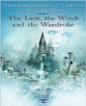 | 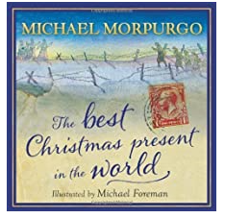 |  |  | Shakespeare  Week | 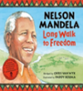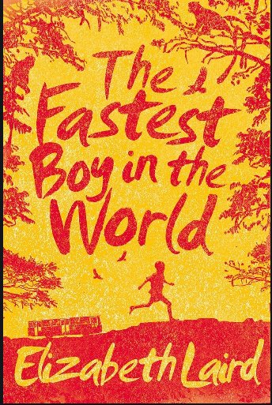
English Reading Y6 | 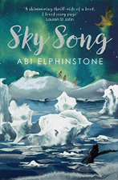 | 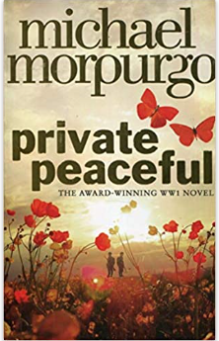 |  |  |  | 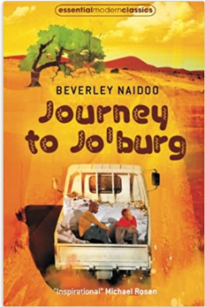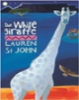
Poetry |  | War Poetry: In Flanders Fields, etc and Wilfred Owen Poems | Doors to the World of Possibility  Pie Corbett Unit |  |  | African Poems & African Poets
English Writing | National Curriculum objectives to be covered progressively using Jonathan Bond’s ‘English Planning Toolkit’ – termly objectives cover speaking and listening, reading and writing.  Progression of text types, with a clear purpose for writing (IPEELL), to be covered over the two-year cycle:  Text types Writing to entertain Writing to inform Writing to persuade Writing to discuss  - Narrative - Descriptions - Poetry (see Pie Corbett poetry spine) - Characters/settings - Report - Recount - Biography - Newspaper article - Essay - Advertising - Letter - Speech - Campaign - Balanced argument - Newspaper article - Review
Maths | White Rose Maths LTPs | White Rose Maths LTPs | White Rose Maths LTPs |  |  | White Rose Maths LTPs
Science  (PLAN) | Forces (B.1) | Light (B.2) | Earth and Space (B.3) | Properties and Changes of Materials:  Reversible and Irreversible changes (B.4) |  | Evolution and inheritance:  Adaptation. (B.5) | Properties and Changes of Materials:  Solutions and mixtures, dissolving and evaporation. (B.6)
 |  |  |  | Science Week
Computing  Y5 | Unit 5.1 Coding | Unit 5.3 Spreadsheets | Unit 5.4 Databases  Unit 5.2 Online Safety | Unit 5.5 Game Creator |  | Unit 5.6 3D Modelling | Unit 5.7 Concept Maps
Computing  Y6 | Unit 6.1 Coding | Unit 6.3 Spreadsheets | Unit 6.6  Networks  Unit 5.2 Online Safety | Unit 6.4 Blogging |  | Unit 6.5  Text Adventures | Unit 6.7  Quizzing
PE Skills  Real PE | Real PE: Unit 1 Cognitive Skills | Real PE: Unit 2 Creative Skills | Real PE: Unit 3 Social Skills in Sport | Real PE: Unit 4  Physical skills |  | Real PE: Unit 5  Health and Fitness. | Real PE: Unit 6  Gymnastics
PE Themes Y5 | Swimming | Dance | Basketball | Orienteering |  | Ultimate Frisbee | Athletics
PE Themes Y6 | Hockey | Gymnastics | Tag Rugby | Netball |  | Kwik Cricket | Swimming
History | Significant event after 1066:  Race to the Pole – Jan 1912  Titanic sinking - April 1912 | WW1 1914-1918  Including Local History Study | Significant event after 1066:  1969 Moon landings |  |  | Significant event after 1066:  Nelson Mandela as President of South Africa  1994-1999
Geography | Location and Place Knowledge  Polar Regions topography, climate, global warming, weather, physical features and compass skills. | Fieldwork: Locality of Brandon  Study pictures of historic elements of a site (Brandon) and compare and contrast. | Location and Place Knowledge and Physical Geography  Map Skills – World Maps, Equator, Lines of Latitude and Longitude,  Earthquakes and Volcanoes – tectonic plates |  |  | Location and Place Knowledge and Human and Physical Geography  Settlement patterns, Rivers (Nile and Zambezi) and African agriculture and trade – diamonds.
 |  |  |  |  |  | Fieldwork Day: River Study.
Art and Design |  | Sculpture: Clay Poppies (Tower of London Poppy installation – ‘Blood Swept Lands and Seas of Red’ by Paul Cummings)  Painting: Using techniques to create effects:  Artist Study: Paul Nash WW1 Paintings |  |  |  | Drawing:  Using techniques to create effects: Sketching techniques: Lions/Giraffes. | Collage  African animal & animal prints
Amazing Artists | Picasso:  1881-1973 | Cezanne:  1839-1906 | Lichtenstein:  1923-1997 | Constable:  1776 – 1837 |  | Georgia O’Keeffe:  1887-1986 | Banksy:  1974 -
Design and Technology | Food  What shape should your pastry be?  Polar Pasty Parcel |  | Electrical Systems  How fast should your buggy be?  Space-themed buggy. | Textiles.  Will your hat be funny or fantastic?  Designing a Harry Potter House themed sorting Hat.
French | Rigolo 2: Unit 7:  Le Week-end | Rigolo 2: Unit 8:  Les Vetements | Rigolo 2: Unit 9: Ma Journee | Rigolo 2: Unit 10: Les Transports |  | Rigolo 2: Unit 11: Les Sports | Rigolo 2: Unit 12: On va faire la fete
Music  Charanga Y5 | Livin’ on a prayer | Classroom Jazz 1 | Make you feel my love | The Fresh Prince of Bel Air |  | Dancing in the Street | Reflect, Rewind, Replay.
Music  Charanga Y6 | Happy | Classroom Jazz 2 | A New year Carol | Music and Me |  | You’ve got a friend in Me | Reflect, Rewind, Replay.
PSHE Y5  (Cambridgeshire Scheme) | Beginning and Belonging  My Emotions | Working Together | Diversity and Communities | Managing Safety and Risk |  | Digital Lifestyles | Relationships and Sex Education  Healthy Lifestyles
PSHE Y6  (Cambridgeshire Scheme) | Rights Rules and Responsibilities  Family and Friends | Anti-bullying | Financial Capability | Drug Education |  | Personal Safety | Relationships and Sex Education  Managing Change
RE | Humanism:  Why do Humanists say happiness is the goal of life? | Christianity:  Why is the Gospel such good news for Christians?  Christmas | Hinduism:  What spiritual pathways to moksha are written about in Hindu scriptures?  Pongal Festival (Jan) | Christianity:  What is the great significance of the ‘Eucharist’ to Christians?  Easter |  | Buddhism:  How does the Triple Refuge help Buddhists in their journey through life?  Buddha Day (May) | Islam:  What does the Qur’an reveal to Muslims about Allah and his guidance?  Hajj (July)
Forest School/Outdoor Learning | Forest School/Outdoor Learning
SMSC Days | Social Day |  | Spiritual Day |  |  | Cultural Day | Moral Day
Enrichment Opportunities | World Mental Health Day  National Poetry Day  ICT/Science @ Adastral Park  G+T Thetford Academy Spelling and Maths Bee  Sports competitions | Christmas Fayre Enterprise  Children in Need Day  School Pantomime Visit  Sports competitions | Young Voices Choir 02 London  Safer Internet Day  World Book Day+ Author Visit  Sports Competitions. |  |  | Eaton Vale Residential for Year 6  Summer Fayre  Year 6 Leavers assembly  Careers Fayre  Sports Competitions, Sports Day, Bikeability
Visit  Opportunities | Production of The Lion, The Witch and the Wardrobe! | British History Museum London  Brandon Heritage Centre  Production of War Horse – if showing | National Space Centre  Harry Potter Studio Tour |  |  | The Lion King  Crucial Crew PHSE Year 6

