Forest Academy Long Term Plan
Nursery
Term | Autumn 1st | Autumn 2nd | Spring 1st | Spring 2nd | Summer 1st | Summer 2nd
Topic | Colour, colour everywhere | Our world… | …and beyond | Glorious Growing | Once upon a rhyme | Pirates Ahoy!
Nursery  Books | 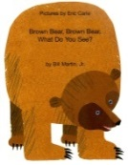 | 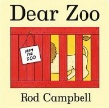 |  | 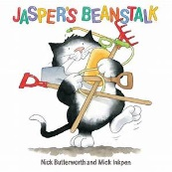 | 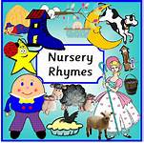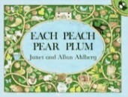  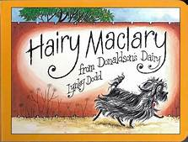
Nursery Rhymes and Poems | Rhyme/Poem of the week
Literacy | Favourite characters  Favourite colours  Retelling stories  Innovating stories | Retelling stories  Innovating stories  Talking about our pets | Non-fiction books  Picking own ideas  Learning new words  Developing own stories  Listening to sounds  Sound of the week | Retelling stories  Sequencing stories  Innovating stories  Following directions  Sound of the week  Asking questions | Rhyme and alliteration  Predicting endings  Following directions  Asking questions  Describing main characters  Looking at books carefully | Describing characters and settings  Story mapping  Rhyme and alliteration  Listens as part of group  Asking questions
Maths | Introducing numbers 1-5  Numbers in our environment  Shapes in our environment  Matching shapes | Introducing numbers 1-5  Comparing numbers of objects  Numbers and shapes in our environment  Building with shapes | Matching numerals to objects  Comparing amounts of objects  Using shapes for a purpose  Positional language  Representing numbers with fingers | Ordering size  Counting out a number of objects  Counting actions  Comparing groups of objects | Numbers 1-10  Ordering objects by size  Patterns | Numbers 1-10  Matching numerals to quantity  Money  Representing numbers  Positional language  2d and 3d shapes
Understanding of the World | Colours  Matching colours  Colours in our world  Noticing changes  Using ICT | Comparing different places  Animals  Looking after animals  Celebrations  Using ICT | Light and dark  Different planets  Floating and sinking  Exploring textures Using ICT | Growing plants  Butterfly lifecycle  Looking at changes  Using ICT | Show care and concern for living things and our environment  Know some of the things that make us unique  Using ICT | Drawing maps  Show an interest in different ways of life  Talk about why things happen and how things work.  Using ICT
Physical Development | Using tools  Malleable materials  Dough disco  Gross and fine motor skills | Using tools  Malleable materials  Dough disco  Gross and fine motor skills | Using tools  Malleable materials  Dough disco  Gross and fine motor skills | Using tools  Malleable materials  Dough disco  Gross and fine motor skills | Using tools  Malleable materials  Dough disco  Gross and fine motor skills | Using tools  Malleable materials  Dough disco  Gross and fine motor skills
Expressive Arts and Design | Colour mixing  Home corner roleplay  Singing colour songs | Textures  Vets roleplay  Singing Christmas songs  Painting | Using different tools  Space rocket roleplay  Changing sounds | Fruit and vegetable Shop roleplay  Textured pictures  Using instruments | Using a range of resources  Singing known songs  Playing instruments  Describing textures | Travel agents roleplay  Moving to music  Use a range of construction
PSED | Separating from carers  Exploring new activities  Getting to know my adults and friends | Forest school rules  Tidy up routines  Sharing resources  Being confident in our environment | Who is in my class?  Who is in my family?  What is important to me?  Safety circle  Internet safety | Taking turns  Playing as part of a group  Talk about home and community  Understanding a range of feelings | What scares us?  Feelings  Sharing with my friends  Taking my turn | Confident to do activities independently.  Working as part of a group  More outgoing in new situations  Moving on to school.
Forest Schools/  Outdoor Learning |  | Forest schools | Forest schools | Forest schools | Forest schools | Forest schools
SMSC Days | Social Day |  | Spiritual Day |  | Cultural Day | Moral Day
Enrichment Opportunities |  | Stay and Play  Children in Need  Guy Fawkes  Christmas Performances | Stay and Play  Safer Internet Day  World Book Day | Stay and Play  Science Week  Shakespeare Week | Stay and Play | Sports Day
Visit Opportunities |  |  |  |  |  | Sea Life Centre

