September 2020
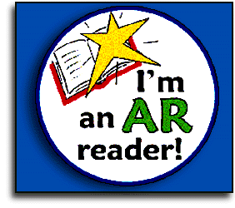
Dear Parents/Carers,
In Key Stage 2, we are continuing to use a program designed to inspire a love of reading and develop children’s comprehension skills. This is called Accelerated Reader.
What is Accelerated Reader?
Accelerated Reader (AR) is a computer program that helps teachers manage and monitor children’s independent reading practice. Your child picks a book at their own level and reads it at their own pace. When finished, your child takes a short quiz on the computer. (Passing the quiz is an indication that your child understood what was read.) AR gives both children and teachers feedback based on the quiz results, which the teacher then uses to help your child set targets and direct ongoing reading practice.
Shortly, all children will be given an individual log in, which enables them to access the program and should be written in the front of their reading journals. You will also receive a letter which tells you the book band they are on e.g. green. This band has been chosen for your child based on their results from a short online assessment, focusing on their ability to decode words and their level of understanding.
Children are encouraged to log in when they have finished reading either their Accelerated Reader book or a book from ‘Forest’s Fantastic Reads’ and complete the quiz for this text. Prizes are awarded for reaching 1,000,000,000 words read and can be accumulated over their time in Key Stage 2.
It is important you use the website address specific to Forest Academy:
https://ukhosted75.renlearn.co.uk/2244962/
Further information will be available at the Parents Evenings.
Thank you,
Mrs Gough
