 | Forest Academy Long-Term Plan 2021-22
 | Year 3 and Year 4 (LKS2) Cycle A
Term | Autumn 1st | Autumn 2nd | Spring 1st and 2nd |  |  | Summer 1st | Summer 2nd
Topic | Local Area/Stone Age | From Land’s End to John O’ Groats  (UK Study) | Ancient Egypt |  |  | When in Rome! | Extreme Earth
English Reading Y3 | 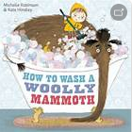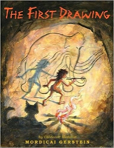 | 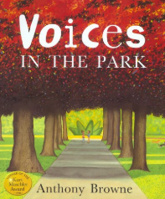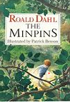 | 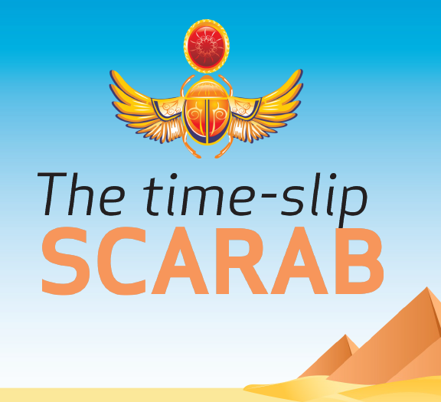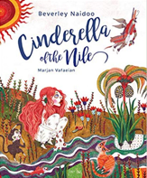 |  | Shakespeare Week | 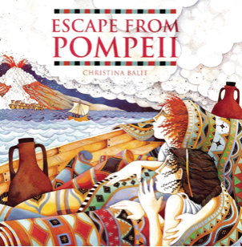 | 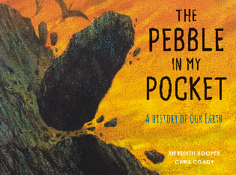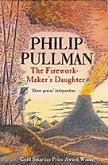
English Reading Y4 | 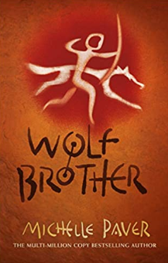 | 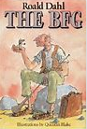 | 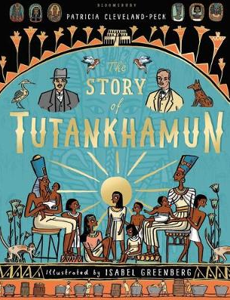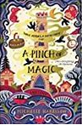 |  |  |  | 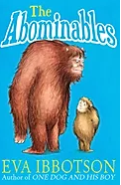
Poetry |  | Deep in the Green Wood – Wes Magee | Paint me a Poem: new poems inspired by art in the Tate – Grace Nicolls |  |  |  | Hot like Fire – Varier Bloom
English Writing | National Curriculum objectives to be covered progressively using Jonathan Bond’s ‘English Planning Toolkit’ – termly objectives cover speaking and listening, reading and writing.  Progression of text types, with a clear purpose for writing (IPEELL), to be covered over the two-year cycle:  Text types Writing to entertain Writing to inform Writing to persuade  - Stories - Description - Poetry (see Pie Corbett’s Poetry Spine) - Characters/settings - Explanation - Recount - Letter - Biography - Newspaper article - Advertising - Letter - Speech - Poster
Maths | White Rose Maths LTPs | White Rose Maths LTPs | White Rose Maths LTPs |  |  | White Rose Maths LTPs |  | White Rose Maths LTPs
Science  (PLAN) | Plants | Electricity | Light |  |  | Forces & Magnets |  | Rocks
 |  |  | Science Week – whole school theme
Computing  Y3 | Unit 3.1 Coding | Unit 3.2 Online safety  Unit 3.3 Spreadsheets | Unit 3.6 Branching Databases | Unit 3.7 Simulations  Unit 3.4 Touch-typing |  | Unit 3.5 Email |  | Unit 3.8 Graphing
Computing  Y4 | Unit 4.1 Coding | Unit 4.2 Online Safety  Unit 4.7 Effective searching | Unit 4.3 Spreadsheets | Unit 4.4 Writing for different audiences |  | Unit 4.5 Logo |  | Unit 4.6 Animation  Unit 4.8 Hardware investigators
PE Skills  Real PE | Unit 1  Developing personal skills | Unit 2  Developing social skills | Unit 3  Developing cognitive skills-problem solving | Unit 4  Developing creative skills |  | Unit 5  Developing physical skills |  | Unit 6  Health and Fitness
PE Themes Y3 | Athletics | Dance | Football | Swimming |  | Swimming |  | Tri-golf
PE Themes Y4 | Hockey | Swimming | Swimming | Gymnastics |  | Mini-tennis |  | Kwick Cricket
History | Changes in Britain from the Stone Age to the Iron Age |  | The achievements of the earliest civilisations – focus on Ancient Egypt |  |  | The Roman Empire and it’s impact on Britain
Geography | Human Geography  Why did the Stone Age civilisation choose to settle where it did? Study of how land was used during this period in the local area – Grimes Graves | Location Knowledge  Name and locate the counties and cities of the UK, identifying features such as hills, mountains, coasts and rivers.  Land use over time, including key industries in the local area e.g. flint mines, Warren Lodge in Thetford (rabbits). | Physical Geography  The River Nile and it’s importance to the Ancient Egyptians – fertile land compared to the surrounding desert, a source of building materials, transportation, the three seasons (flooding, the growing season, the harvest season). |  |  |  |  | Physical Geography  The Earth beneath our feet. Mountains and Volcanoes – where do they occur, what causes them, how do they erupt?
Art and Design | Drawing  The Dordogne, France: Lascaux's Prehistoric Cave Paintings |  | Sculpture Egyptian artefacts (wire & plaster) |  |  | Printing  Mosaics
Amazing Artists | Matisse:  1869 -1954 | Van Gogh:  1853-1890 | Kandinsky:  1866-1944 | Turner:  1775-1851 |  | Seurat:  1859-1891 |  | Frida Kahlo:  1907-1954
Design and Technology |  | Electrical systems: Simple circuits and switches  What sort of light will work for you? |  | Mechanisms: Levers & linkages  Will this story surprise you? |  |  |  | Food  How do you take your tea?
French | Rigolo 1  Unit 1: Bonjour! | Rigolo 1  Unit 2: En class | Rigolo 1  Unit 3: Mon corps | Rigolo 1  Unit 4: Les animaux |  | Rigolo 1  Unit 5: La famille |  | Rigolo 1  Unit 6: Bon anniversaire
Music  Charanga Y3 | Let your spirit fly | Glockenspiel 1 | Three little birds  The dragon song |  |  | Bring us together |  | Reflect, Rewind and Replay
Music  Charanga Y4 | Mamma Mia | Glockenspiel 2 | STOP!  Lean on me |  |  | Blackbird |  | Reflect. Rewind and Replay
PSHE Y3  (Cambridgeshire Scheme) | Beginning and Belonging  My Emotions | Working Together | Diversity and Communities | Managing Safety and Risk |  | Digital Lifestyles |  | Relationships and Sex Education  Healthy Lifestyles
PSHE Y4  (Cambridgeshire Scheme) | Rights Rules and Responsibilities  Family and Friends | Anti-bullying | Financial Capability | Drug Education |  | Personal Safety |  | Relationships and Sex Education  Managing Change
RE | Hinduism  How does the story of Rama and Sita inspire Hindus to follow their dharma? | Christianity  How does believing Jesus is their saviour inspire Christians to save and serve others? | Christianity |  |  | Islam  Why do Muslims call Muhammad the ‘Seal of the Prophets’? |  | Sikhism  How does the teaching of the gurus move Sikhs from dark to light?
 |  |  | How do Christians show that reconciliation with God and other people is important? | Why do Christians believe they are people on a mission?
Forest Schools/Outdoor learning | Forest Schools/Outdoor learning
SMSC Days | Social Day |  | Spiritual Day |  |  | Cultural Day |  | Moral Day
Enrichment Opportunities | Open the tent: The story of Rama and Sita  World Mental Health Day  National Poetry Day (October)  Harvest Festival | David Hockney day – famous artist study  Children in Need – charity event  Pantomime visit  Christmas carols in the community | Safer Internet Day (February)  World Book Day (March)  Computational thinking – Adastral Park (Year 3)  Divergent drama – Shakespeare  LKS2 Production  Young Voices |  |  | Link to Dubai school – Ramadan |  | Sports Day  French cafe
Visit  Opportunities | Grimes Graves (Fieldwork) |  | Fitzwilliam Museum  School Farm and Country Fair – Yr 3 (April) |  |  | Colchester Castle |  | Guru Nanak Gurdwara (Ipswich)  Kiidzania

