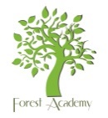 | Forest Academy Long Term Plan  Reception
Term | Autumn 1st | Autumn 2nd | Spring 1st | Spring 2nd | Summer 1st | Summer 2nd
Topic | Down on the Farm | Frozen Worlds | The Sky Above | Going on a Journey | Kingdoms and Castles | Once Upon a Story
Literacy Core Texts  (Talk for Writing) | 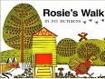  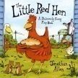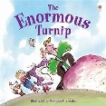 | 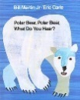  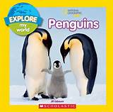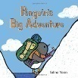 | 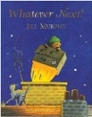  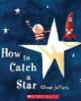 | 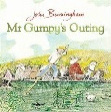  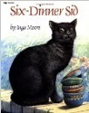 | 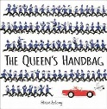  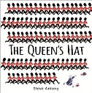 | 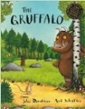  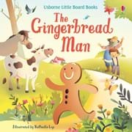
 |  |  |  | Shakespeare Week
Poetry | Poem of the Week
Maths | White Rose Maths LTPs | White Rose Maths LTPs | White Rose Maths LTPs | White Rose Maths LTPs | White Rose Maths LTPs | White Rose Maths LTPs
Understanding of the World

Past and Present | Do we still make bread the same way?  How many mills are operating now? | Eco- friendly  Reduce, Reuse, Recycle & why?  Comparing how our world/land has changed and why | Does the sky always look the same?  What have astronauts found out? | Have we always been able to fly on a plane/ drive to school? | Do we build castles today? | Has Brandon always looked like this?
People, Culture and Communities | RE Unit  Why is the word God so important to Christians? | RE Unit  How can we care for our wonderful world? | RE Unit  Why do Christians perform Nativity plays at Christmas? | RE Unit  What makes every single person unique and precious? | RE Unit  Why do Christians put a cross in an Easter Garden? | RE Unit  How can we help others when they need it?
The Natural World | Making bread  Comparing vegetables  Making turnip soup | Exploring the properties of ice  Polar animals  Comparing habitats | Planets  Solar system  Aurora lights | Journeys – travel  Map work – drawing a map/ journey  Floating & sinking | Modes of transport  Landmarks in GB  Local landmarks | Local forest habitat  Forest animals & wild animals
Physical Development
Gross Motor Skills | Real PE Unit  Unit 1 | Real PE Unit  Unit 2 | Real PE Unit  Unit 3 | Real PE Unit  Unit 4 | Real PE Unit  Unit 5 | Real PE Unit  Unit 6
 | Balanceability | Yoga | Dance | Gymnastics | Balanceability | Balanceability
Fine Motor Skills | Kneading dough  Cutting vegetables  Grinding corn | Breaking ice – different tools.  Ice writing  Tweezers and ice | Threading stars  Pegging & matching numbered stars  Mark making in shaving foam etc | Making Easter baskets  Cotton bud painting  Potato printing | Vehicle tracks in paint  Finger painting art  Stickers on large Letter-Join letters | Salt dough models  Cheerio challenge  Ice cream shop role play
Expressive Arts and Design
Creating with Materials | Salt dough creations  Design & Make your own sandwich | Making igloos and houses – junk modelling/sugar cubes/construction | Decorating stars  Making stars from natural resources  Design, plan, make & evaluate -rockets | Design, plan, make & evaluate; boats & other transport  Playdough/clay vehicles | Make your own castle in the forest  Make a junk box castle  Paint/draw/colour | Make Gruffalo Crumble  Design and make Gingerbread men  Clay animals
Performing  (Charanga Unit) | Me! | My stories | Everyone! | Our World | Big Bear Funk | Reflect, Rewind and Replay
PSED  (Cambridgeshire Scheme) | Beginning and Belonging  My Family and Friends including Anti-Bullying | My Emotions | Identities and Diversity | Me and My World | My Body and Growing Up | Keeping Safe  Healthy Lifestyles
Forest Schools/Outdoor Learning | Forest rules  Rosie’s walk – prepositions  Scavenger hunt – size language/ordering  Team work – creative make & do | Forest rules  Forest art –using natural resources  Journey’s through the forest –  Retelling stories | Making stars out of natural resources  Making comparisons – sky night and day  Cloud watching | What mode of transport can you make?  We’re going on a journey, (bear hunt repetition)  Science in the forest - volcanoes | Making zip wires  Changes – sims and diffs  Comparing environments  Making our own natural landmarks | Making dens  Mini-beast hunts  Comparing the Gruffalo forest to our forest (sims & diffs)
SMSC Days | Social Day |  | Spiritual Day |  | Cultural Day | Moral Day
Enrichment Opportunities | Chicken or farm animals  Tractor visit  World mental health day  National Poetry Day (October) | Children in Need  Christmas Performance and watching other Key stages  Maraiker Puppets | Safer Internet Day (Feb)  Watch live webcams of international space station/videos | World Book Day (March)  Science week  Scientist to visit | Visit a local landmark in town | Sports Day  Local walk to Brandon Country Park  Maraiker Puppets
Visit Opportunities | Visit a local farm |  | Planetarium (in school) |  | Norwich Castle

